CAPSTONE -2

CUSTOMER RELATIONSHIP MANAGEMENT SYSTEM (CRM)

--CAPSTONE (2)

/* CUSTOMER RELATIONSHIP MANAGEMENT SYSTEM (CRM) */

--CREATING DATABASE

CREATE DATABASE Capstone2;

USE Capstone2;

--THIS DATABASE CONSIST OF TABLES CUSTOMER,ACCOUNTS,TRANSACTION,CUSTOMER SERVICE,FEEDBACK.

-- CREATING CUSTOMER TABLE

CREATE TABLE customers (

customerID INT PRIMARY KEY,

FirstName VARCHAR(50),

LastName VARCHAR(50),

DateOfBirth DATE,

JoiningDate DATE,

Email VARCHAR(100)

);

-- CREATING ACCOUNTS TABLE

CREATE TABLE accounts (

accountID INT PRIMARY KEY,

customerID INT FOREIGN KEY REFERENCES customers(customerid),

accountType VARCHAR(50),

Balance DECIMAL(18, 2),

OpeningDate DATE,

Status VARCHAR(20),

);

-- CREATING TRANSACTION TABLE

CREATE TABLE transactions (

transactionID INT PRIMARY KEY,

accountID INT FOREIGN KEY REFERENCES accounts(accountID),

Date DATE,

Amount DECIMAL(18, 2),

TransactionType VARCHAR(50),

Description VARCHAR(255),

);

-- CREATING CUSTOMER SERVICE TABLE

CREATE TABLE customerservice (

interactionID INT PRIMARY KEY,

customerID INT FOREIGN KEY REFERENCES customers(customerID),

Date DATE,

InteractionType VARCHAR(50),

Description VARCHAR(255),

ResolutionStatus VARCHAR(50),

);

-- CREATING FEEDBACK TABLE

CREATE TABLE feedback (

feedbackID INT PRIMARY KEY,

customerID INT FOREIGN KEY REFERENCES customers(customerID),

Date DATE,

Score INT,

Comments VARCHAR(255),

); 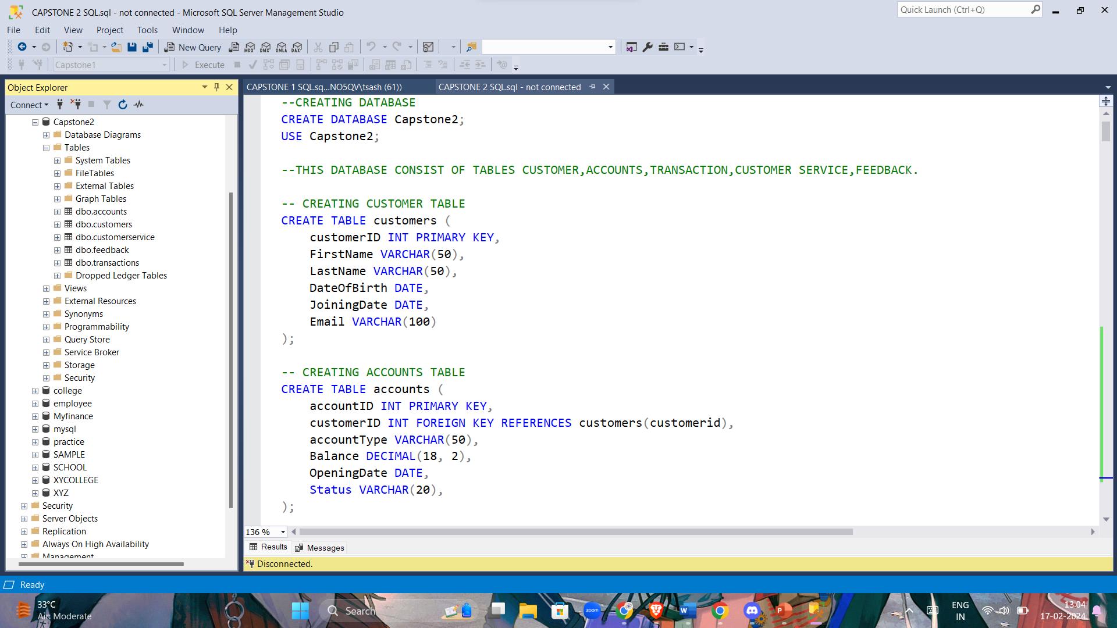

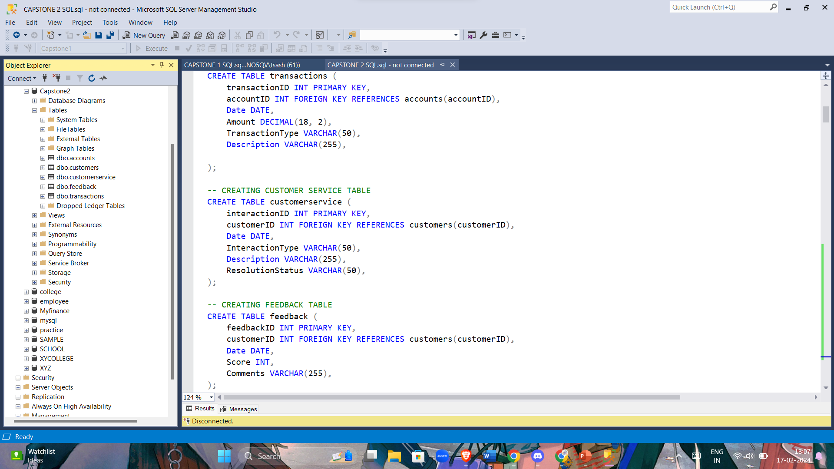

--INSERTING DATA INTO THE TABLES

-- INSERTING SAMPLE DATA IN CUSTOMER TABLE

INSERT INTO customers (customerID, FirstName, LastName, DateOfBirth, JoiningDate, Email)

VALUES

(1, 'Aarav', 'Patel', '1992-03-15', '2010-05-20', 'aarav.p@gmail.com'),

(2, 'Aisha', 'Sharma', '1988-06-25', '2012-07-10', 'aisha.sh@gmail.com'),

(3, 'Arjun', 'Gupta', '1985-02-10', '2009-09-05', 'arjun.g@gmail.com'),

(4, 'Ananya', 'Singh', '1992-11-20', '2015-03-15', 'ananya.s@gmail.com'),

(5, 'Ishaan', 'Verma', '1987-04-30', '2011-11-25', 'ishaan.v@gmail.com'),

(6, 'Khushi', 'Kumar', '1994-07-12', '2018-01-28', 'khushi.k@gmail.com'),

(7, 'Riya', 'Reddy', '1983-09-05', '2007-08-10', 'riya.r@gmail.com'),

(8, 'Vihaan', 'Yadav', '1991-03-18', '2013-06-20', 'vihaan.y@gmail.com'),

(9, 'Saanvi', 'Malhotra', '1990-09-21', '2010-02-12', 'saanvi.m@gmail.com'),

(10, 'Advik', 'Bose', '1989-01-05', '2014-05-30', 'advik.b@gmail.com'),

(11, 'Anika', 'Chopra', '1986-07-02', '2008-04-17', 'anika.c@gmail.com'),

(12, 'Kabir', 'Rai', '1993-12-11', '2016-10-22', 'kabir.r@gmail.com'),

(13, 'Pari', 'Nair', '1984-05-08', '2017-09-08', 'pari.n@gmail.com'),

(14, 'Rehan', 'Dutta', '1992-08-03', '2019-11-14', 'rehan.d@gmail.com'),

(15, 'Shreya', 'Mukherjee', '1988-11-17', '2011-03-19', 'shreya.m@gmail.com'),

(16, 'Vivaan', 'Joshi', '1983-04-26', '2009-08-07', 'vivaan.j@gmail.com'),

(17, 'Zoya', 'Shah', '1995-02-28', '2018-12-31', 'zoya.s@gmail.com'),

(18, 'Ansh', 'Gandhi', '1991-07-07', '2013-04-02', 'ansh.g@gmail.com'),

(19, 'Ishika', 'Das', '1989-06-14', '2016-09-25', 'ishika.d@gmail.com'),

(20, 'Kabir', 'Banerjee', '1987-10-09', '2010-11-16', 'kabir.b@gmail.com'),

(21, 'Ria', 'Sen', '1993-03-24', '2015-08-05', 'ria.s@gmail.com'),

(22, 'Shaurya', 'Roy', '1984-01-19', '2008-12-10', 'shaurya.r@gmail.com'),

(23, 'Yashika', 'Mehta', '1986-06-28', '2012-06-23', 'yashika.m@gmail.com'),

(24, 'Aayush', 'Sinha', '1990-08-07', '2017-10-11', 'aayush.s@gmail.com'),

(25, 'Anvi', 'Kapoor', '1988-12-04', '2019-04-27', 'anvi.k@gmail.com'),

(26, 'Dhruv', 'Sharma', '1994-10-31', '2011-07-14', 'dhruv.s@gmail.com'),

(27, 'Ira', 'Patil', '1985-09-16', '2013-11-02', 'ira.p@gmail.com'),

(28, 'Kabir', 'Naidu', '1992-11-23', '2015-12-18', 'kabir.n@gmail.com'),

(29, 'Parth', 'Shah', '1987-07-30', '2009-06-29', 'parth.s@gmail.com'),

(30, 'Riyaan', 'Singh', '1991-05-05', '2014-09-24', 'riyaan.s@gmail.com'),

(31, 'Vidhi', 'Rao', '1986-03-12', '2016-08-03', 'vidhi.r@gmail.com'),

(32, 'Zara', 'Mishra', '1993-04-20', '2018-02-19', 'zara.m@gmail.com');

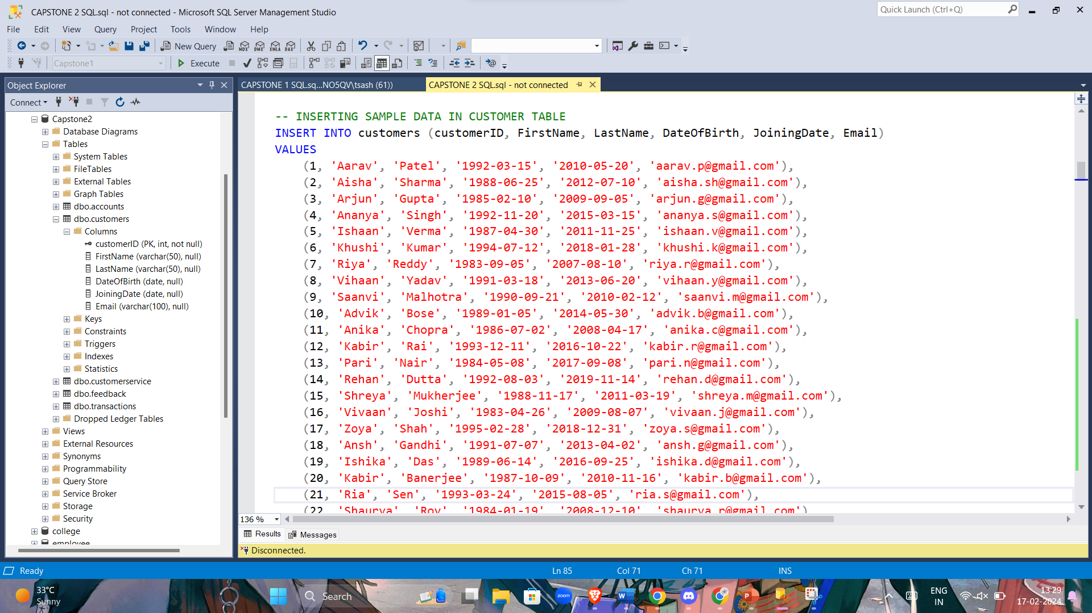

-- INSERTING SAMPLE DATA IN ACCOUNTS TABLE

INSERT INTO accounts (accountID, customerID, AccountType, Balance, OpeningDate, Status)

VALUES

(101, 1, 'Savings', 50000.00, '2010-05-20', 'Active'),

(102, 2, 'Checking', 75000.00, '2012-07-10', 'Active'),

(103, 3, 'Savings', 100000.00, '2009-09-05', 'Active'),

(104, 4, 'Checking', 60000.00, '2015-03-15', 'Active'),

(105, 5, 'Savings', 90000.00, '2011-11-25', 'Active'),

(106, 6, 'Checking', 120000.00, '2018-01-28', 'Active'),

(107, 7, 'Savings', 80000.00, '2007-08-10', 'Active'),

(108, 8, 'Checking', 95000.00, '2013-06-20', 'Active'),

(109, 9, 'Savings', 55000.00, '2010-02-12', 'Active'),

(110, 10, 'Checking', 72000.00, '2014-05-30', 'Active'),

(111, 11, 'Savings', 97000.00, '2008-04-17', 'Active'),

(112, 12, 'Checking', 63000.00, '2016-10-22', 'Active'),

(113, 13, 'Savings', 85000.00, '2017-09-08', 'Active'),

(114, 14, 'Checking', 110000.00, '2019-11-14', 'Active'),

(115, 15, 'Savings', 60000.00, '2011-03-19', 'Active'),

(116, 16, 'Checking', 80000.00, '2009-08-07', 'Active'),

(117, 17, 'Savings', 105000.00, '2018-12-31', 'Active'),

(118, 18, 'Checking', 92000.00, '2013-04-02', 'Active'),

(119, 19, 'Savings', 75000.00, '2016-09-25', 'Active'),

(120, 20, 'Checking', 80000.00, '2010-11-16', 'Active'),

(121, 21, 'Savings', 92000.00, '2015-08-05', 'Active'),

(122, 22, 'Checking', 84000.00, '2008-12-10', 'Active'),

(123, 23, 'Savings', 78000.00, '2012-06-23', 'Active'),

(124, 24, 'Checking', 98000.00, '2017-10-11', 'Active'),

(125, 25, 'Savings', 70000.00, '2019-04-27', 'Active'),

(126, 26, 'Checking', 87000.00, '2011-07-14', 'Active'),

(127, 27, 'Savings', 89000.00, '2013-11-02', 'Active'),

(128, 28, 'Checking', 92000.00, '2015-12-18', 'Active'),

(129, 29, 'Savings', 62000.00, '2009-06-29', 'Active'),

(130, 30, 'Checking', 95000.00, '2014-09-24', 'Active'),

(131, 31, 'Savings', 85000.00, '2016-08-03', 'Active'),

(132, 32, 'Checking', 78000.00, '2018-02-19', 'Active');

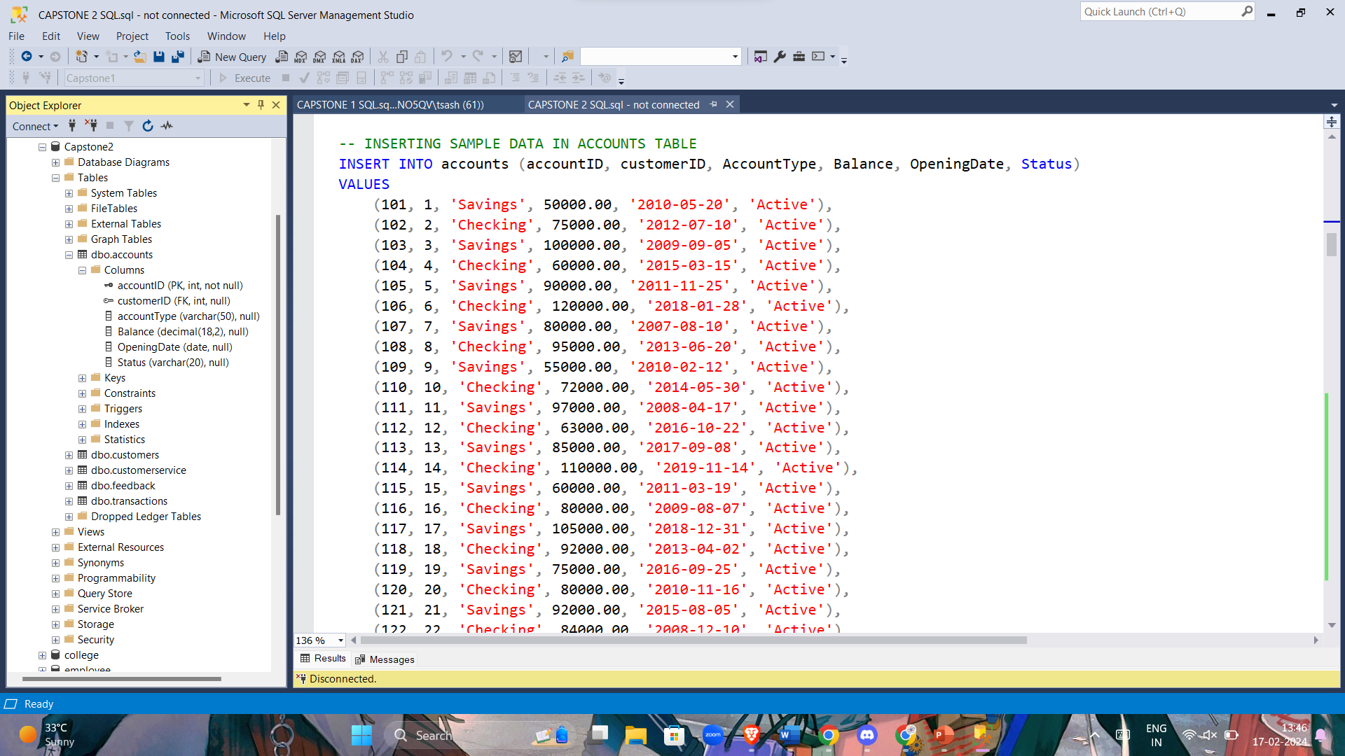

-- INSERTING SAMPLE DATA IN TRANSACTION TABLE

INSERT INTO transactions (transactionID, accountID, Date, Amount, TransactionType, Description)

VALUES

(201, 101, '2024-02-12', 5000.00, 'Deposit', 'Salary deposit'),

(202, 102, '2024-02-11', 2500.00, 'Deposit', 'Bonus deposit'),

(203, 103, '2024-02-10', 3000.00, 'Withdrawal', 'Shopping expenses'),

(204, 104, '2024-02-09', 1500.00, 'Withdrawal', 'Grocery shopping'),

(205, 105, '2024-02-08', 2000.00, 'Deposit', 'Savings deposit'),

(206, 106, '2024-02-07', 4000.00, 'Deposit', 'Investment returns'),

(207, 107, '2024-02-06', 1000.00, 'Withdrawal', 'Utility bill payment'),

(208, 108, '2024-02-05', 3500.00, 'Withdrawal', 'Dining out'),

(209, 109, '2024-02-04', 2200.00, 'Deposit', 'Bonus deposit'),

(210, 110, '2024-02-03', 2800.00, 'Deposit', 'Salary deposit'),

(211, 111, '2024-02-02', 2600.00, 'Withdrawal', 'Shopping expenses'),

(212, 112, '2024-02-01', 1700.00, 'Withdrawal', 'Grocery shopping'),

(213, 113, '2024-01-31', 2100.00, 'Deposit', 'Savings deposit'),

(214, 114, '2024-01-30', 3800.00, 'Deposit', 'Investment returns'),

(215, 115, '2024-01-29', 1500.00, 'Withdrawal', 'Utility bill payment'),

(216, 116, '2024-01-28', 2900.00, 'Withdrawal', 'Dining out'),

(217, 117, '2024-01-27', 2300.00, 'Deposit', 'Bonus deposit'),

(218, 118, '2024-01-26', 2700.00, 'Deposit', 'Salary deposit'),

(219, 119, '2024-01-25', 2500.00, 'Withdrawal', 'Shopping expenses'),

(220, 120, '2024-01-24', 1800.00, 'Withdrawal', 'Grocery shopping'),

(221, 121, '2024-01-23', 2000.00, 'Deposit', 'Savings deposit'),

(222, 122, '2024-01-22', 3500.00, 'Deposit', 'Investment returns'),

(223, 123, '2024-01-21', 1200.00, 'Withdrawal', 'Utility bill payment'),

(224, 124, '2024-01-20', 3100.00, 'Withdrawal', 'Dining out'),

(225, 125, '2024-01-19', 2400.00, 'Deposit', 'Bonus deposit'),

(226, 126, '2024-01-18', 2600.00, 'Deposit', 'Salary deposit'),

(227, 127, '2024-01-17', 2900.00, 'Withdrawal', 'Shopping expenses'),

(228, 128, '2024-01-16', 1700.00, 'Withdrawal', 'Grocery shopping'),

(229, 129, '2024-01-15', 2200.00, 'Deposit', 'Savings deposit'),

(230, 130, '2024-01-14', 3800.00, 'Deposit', 'Investment returns'),

(231, 131, '2024-01-13', 1500.00, 'Withdrawal', 'Utility bill payment'),

(232, 132, '2024-01-12', 2900.00, 'Withdrawal', 'Dining out');

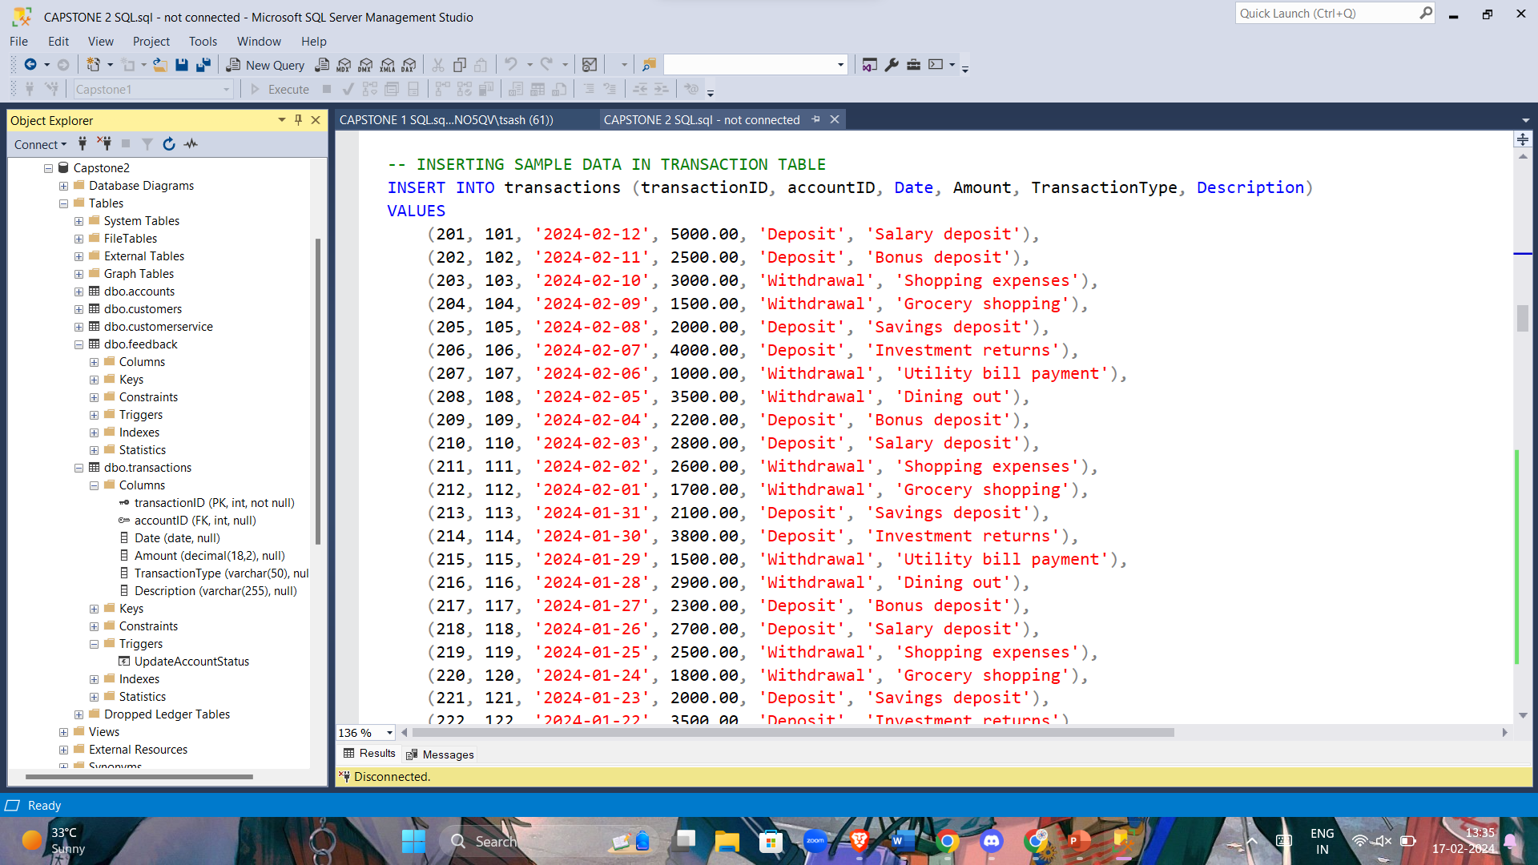

-- INSERTING SAMPLE DATA IN CUSTOMER SERVICE TABLE

INSERT INTO customerservice (interactionID, customerID, Date, InteractionType, Description, ResolutionStatus)

VALUES

(301, 1, '2024-02-12', 'Complaint', 'Issue with online banking', 'Resolved'),

(302, 2, '2024-02-11', 'Query', 'Balance discrepancy', 'Pending'),

(303, 3, '2024-02-10', 'Complaint', 'Credit card declined', 'Resolved'),

(304, 4, '2024-02-09', 'Query', 'Transaction not reflecting', 'Resolved'),

(305, 5, '2024-02-08', 'Complaint', 'Incorrect account statement', 'Pending'),

(306, 6, '2024-02-07', 'Query', 'Lost debit card', 'Pending'),

(307, 7, '2024-02-06', 'Complaint', 'Unauthorized transaction', 'Resolved'),

(308, 8, '2024-02-05', 'Query', 'Forgot internet banking password', 'Resolved'),

(309, 9, '2024-02-04', 'Complaint', 'Transaction error', 'Pending'),

(310, 10, '2024-02-03', 'Query', 'Loan application status', 'Resolved'),

(311, 11, '2024-02-02', 'Complaint', 'ATM cash withdrawal issue', 'Resolved'),

(312, 12, '2024-02-01', 'Query', 'Credit card limit increase', 'Resolved'),

(313, 13, '2024-01-31', 'Complaint', 'Online payment failure', 'Pending'),

(314, 14, '2024-01-30', 'Query', 'Account statement request', 'Resolved'),

(315, 15, '2024-01-29', 'Complaint', 'Fraudulent activity', 'Resolved'),

(316, 16, '2024-01-28', 'Query', 'PIN reset', 'Resolved'),

(317, 17, '2024-01-27', 'Complaint', 'ATM card not received', 'Resolved'),

(318, 18, '2024-01-26', 'Query', 'Interest rate clarification', 'Resolved'),

(319, 19, '2024-01-25', 'Complaint', 'Delayed transaction', 'Resolved'),

(320, 20, '2024-01-24', 'Query', 'Account closure process', 'Pending'),

(321, 21, '2024-01-23', 'Complaint', 'Bank statement error', 'Resolved'),

(322, 22, '2024-01-22', 'Query', 'Cheque book request', 'Resolved'),

(323, 23, '2024-01-21', 'Complaint', 'Unauthorized deduction', 'Resolved'),

(324, 24, '2024-01-20', 'Query', 'Loan EMI calculation', 'Resolved'),

(325, 9, '2024-01-04', 'Query', 'Account balance discrepancy', 'Resolved'),

(326, 10, '2024-01-03', 'Complaint', 'Unauthorized transaction', 'Resolved'),

(327, 11, '2024-01-02', 'Query', 'Loan application status', 'Pending'),

(328, 12, '2024-01-01', 'Complaint', 'Issue with credit card billing', 'Resolved'),

(329, 13, '2023-12-31', 'Query', 'Transaction not showing in statement', 'Resolved'),

(330, 14, '2023-12-30', 'Complaint', 'Online banking login issue', 'Resolved'),

(331, 15, '2023-12-29', 'Query', 'Interest rate inquiry', 'Resolved'),

(332, 16, '2023-12-28', 'Complaint', 'Unusual account activity', 'Resolved'),

(333, 17, '2023-12-27', 'Query', 'ATM withdrawal limit', 'Resolved'),

(334, 18, '2023-12-26', 'Complaint', 'Delay in fund transfer', 'Pending');

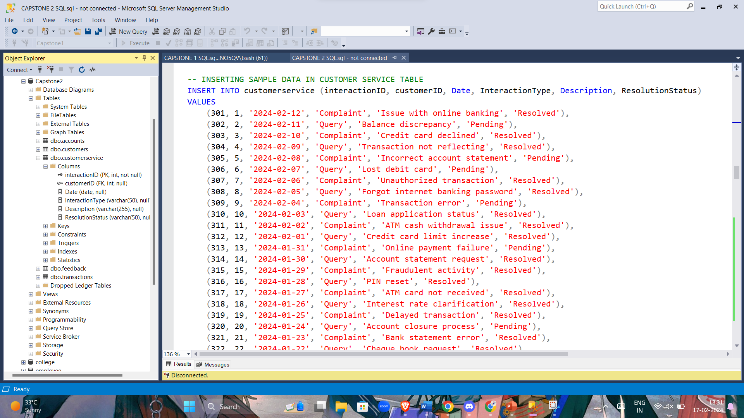

-- INSERTING SAMPLE DATA IN FEEDBACK TABLE

INSERT INTO feedback (feedbackID, customerID, Date, Score, Comments)

VALUES

(401, 1, '2024-02-12', 4, 'Prompt resolution'),

(402, 2, '2024-02-11', 3, 'Satisfactory response'),

(403, 3, '2024-02-10', 5, 'Excellent service'),

(404, 4, '2024-02-09', 2, 'Delayed resolution'),

(405, 5, '2024-02-08', 4, 'Helpful staff'),

(406, 6, '2024-02-07', 3, 'Average response time'),

(407, 7, '2024-02-06', 5, 'Very satisfied'),

(408, 8, '2024-02-05', 4, 'Resolved my issue quickly'),

(409, 9, '2024-02-04', 3, 'Needs improvement in response time'),

(410, 10, '2024-02-03', 4, 'Clear explanation provided'),

(411, 11, '2024-02-02', 2, 'Issue took too long to resolve'),

(412, 12, '2024-02-01', 5, 'Quick and efficient service'),

(413, 13, '2024-01-31', 3, 'Repeated failure in online payments'),

(414, 14, '2024-01-30', 4, 'Received statement promptly'),

(415, 15, '2024-01-29', 5, 'Fraud detected and resolved immediately'),

(416, 16, '2024-01-28', 4, 'PIN reset successfully'),

(417, 17, '2024-01-27', 3, 'Delayed delivery of ATM card'),

(418, 18, '2024-01-26', 5, 'Clear explanation provided'),

(419, 19, '2024-01-25', 4, 'Issue resolved eventually'),

(420, 20, '2024-01-24', 2, 'Slow response in account closure process'),

(421, 21, '2024-01-23', 5, 'Bank statement error rectified'),

(422, 22, '2024-01-22', 4, 'Cheque book received on time'),

(423, 23, '2024-01-21', 5, 'Unauthorized deduction refunded promptly'),

(424, 24, '2024-01-20', 3, 'Confusing loan EMI calculation resolved'),

(425, 25, '2024-01-19', 4, 'Resolved my query efficiently'),

(426, 26, '2024-01-18', 3, 'Response time could be improved'),

(427, 27, '2024-01-17', 5, 'Very satisfied with the service'),

(428, 28, '2024-01-16', 4, 'Helpful customer support'),

(429, 29, '2024-01-15', 2, 'Unresolved issue'),

(430, 30, '2024-01-14', 4, 'Quick resolution'),

(431, 31, '2024-01-13', 3, 'Average service experience'),

(432, 32, '2024-01-12', 5, 'Resolved my complaint promptly'),

(433, 1, '2024-01-11', 4, 'Responsive customer support'),

(434, 2, '2024-01-10', 3, 'Issue resolved after multiple follow-ups');

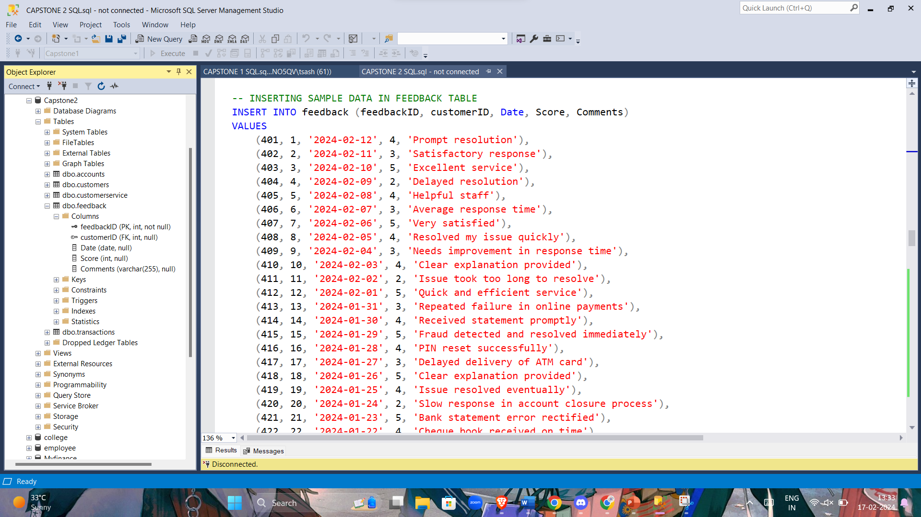

--WRITE A QUERY TO SEGMENT CUSTOMERS BASED ON THEIR TRANSACTION VOLUMES AND ACCOUNT TYPES

SELECT t1.accountType,SUM(t2.amount) AS Transaction_volume

FROM accounts AS t1

INNER JOIN transactions AS t2

ON t1.accountID = t2.accountID

GROUP BY accountType;

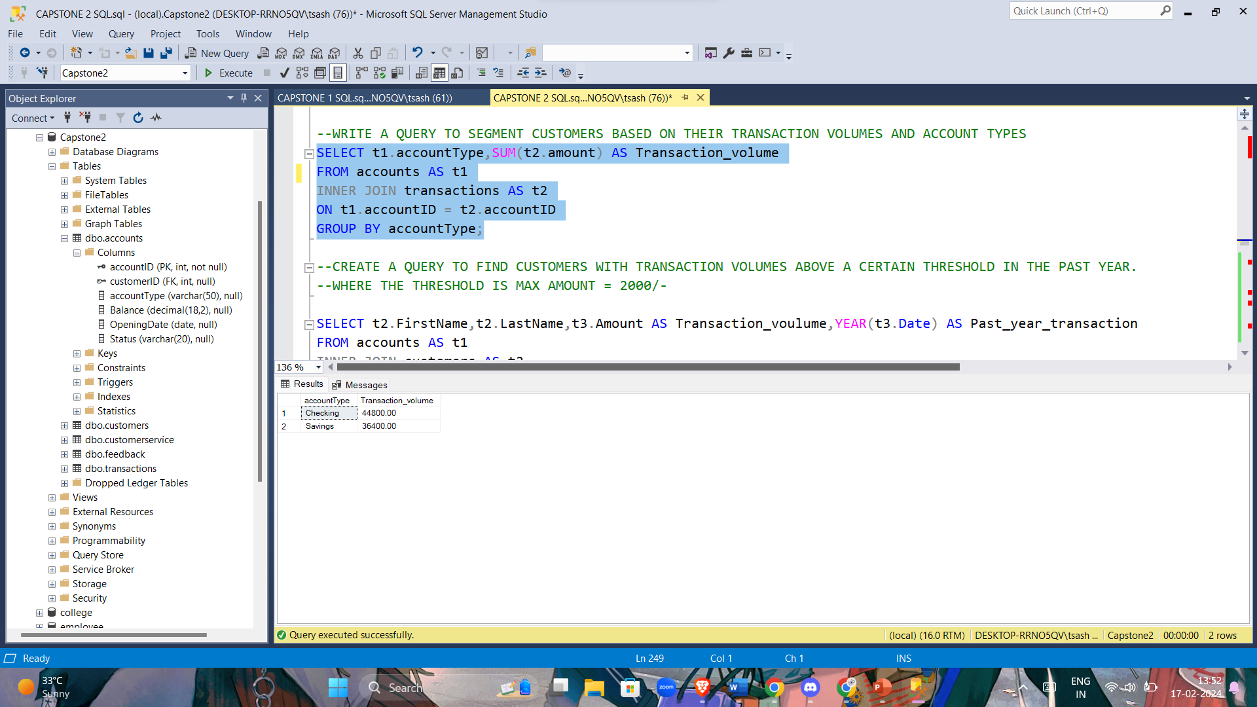

--CREATE A QUERY TO FIND CUSTOMERS WITH TRANSACTION VOLUMES ABOVE A CERTAIN THRESHOLD IN THE PAST YEAR.

--WHERE THE THRESHOLD IS MAX AMOUNT = 2000/-

SELECT t2.FirstName,t2.LastName,t3.Amount AS Transaction_voulume,YEAR(t3.Date) AS Past_year_transaction

FROM accounts AS t1

INNER JOIN customers AS t2

ON t1.customerID = t2.customerID

INNER JOIN transactions AS t3

ON t1.accountID = t3.accountID

WHERE YEAR(t3.Date)> DATEADD(YEAR,-1,GETDATE()) AND Amount>2000;

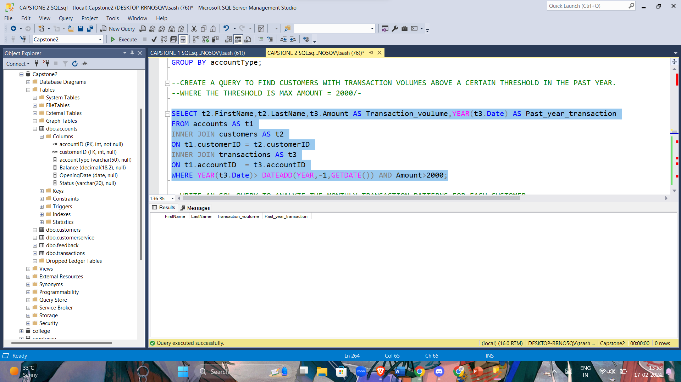

--WRITE AN SQL QUERY TO ANALYZE THE MONTHLY TRANSACTION PATTERNS FOR EACH CUSTOMER.

SELECT t2.FirstName,t2.LastName,t3.Amount,t3.Date,t3.TransactionType,t3.Description

FROM accounts AS t1

INNER JOIN customers AS t2

ON t1.customerID = t2.customerID

INNER JOIN transactions AS t3

ON t1.accountID = t3.accountID

WHERE t2.customerID = 1;

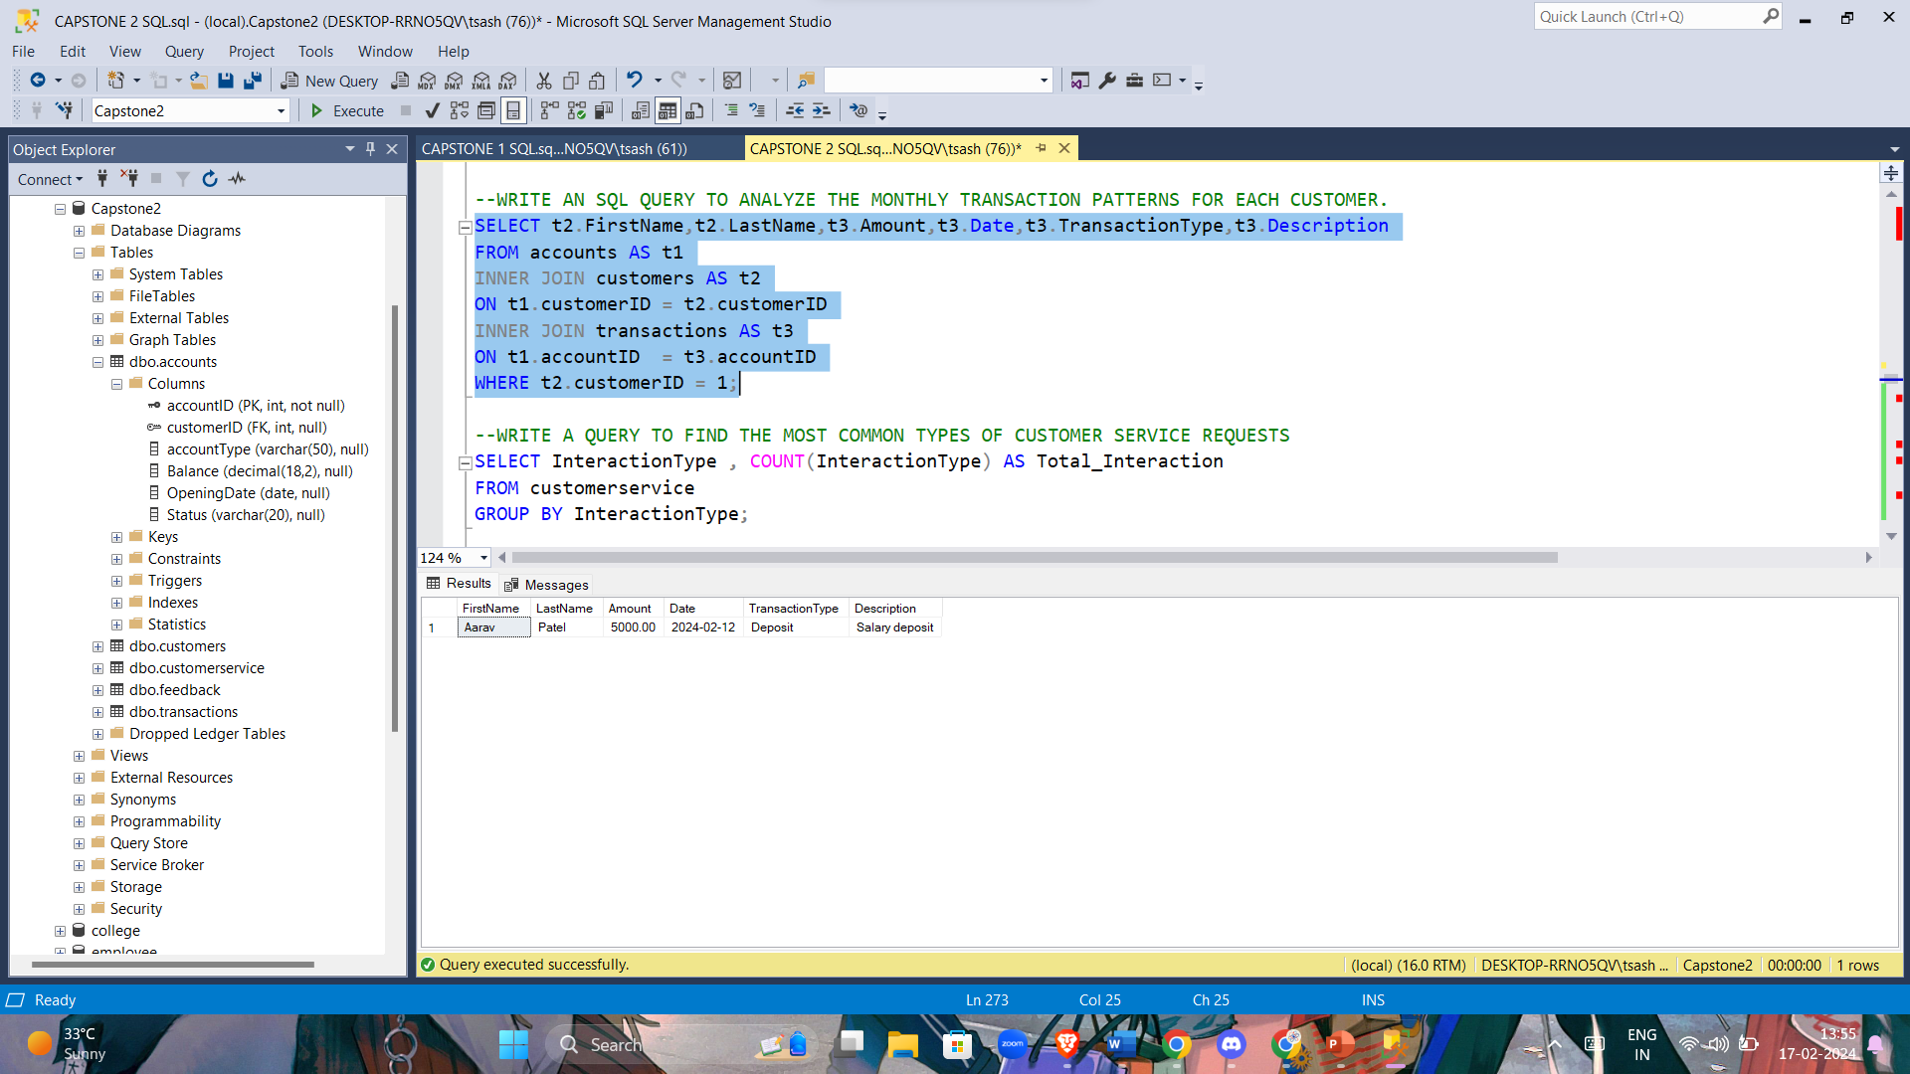

--WRITE A QUERY TO FIND THE MOST COMMON TYPES OF CUSTOMER SERVICE REQUESTS

SELECT InteractionType , COUNT(InteractionType) AS Total_Interaction

FROM customerservice

GROUP BY InteractionType;

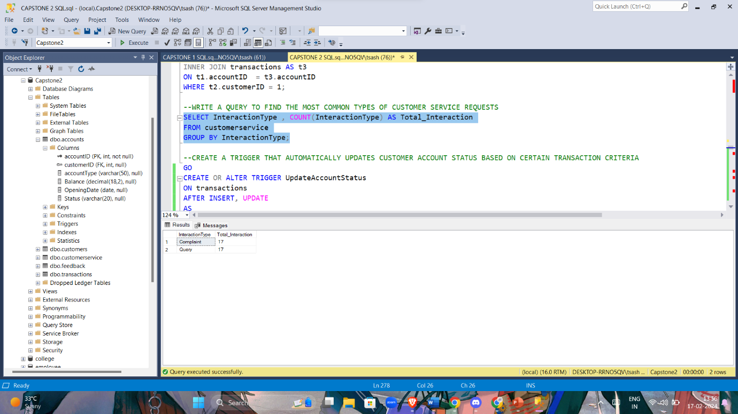

--CREATE A TRIGGER THAT AUTOMATICALLY UPDATES CUSTOMER ACCOUNT STATUS BASED ON CERTAIN TRANSACTION CRITERIA

GO

CREATE OR ALTER TRIGGER UpdateAccountStatus

ON transactions

AFTER INSERT, UPDATE

AS

BEGIN

-- UPDATE ACCOUNT STATUS BASED ON TRANSACTION CRITERIA

UPDATE accounts

SET Status =

CASE

WHEN (SELECT SUM(Amount) FROM inserted WHERE customerID = accounts.customerID) > 3000 THEN 'Gold'

WHEN (SELECT SUM(Amount) FROM inserted WHERE customerID = accounts.customerID) > 2000 THEN 'Silver'

ELSE 'Bronze'

END

FROM accounts

END;

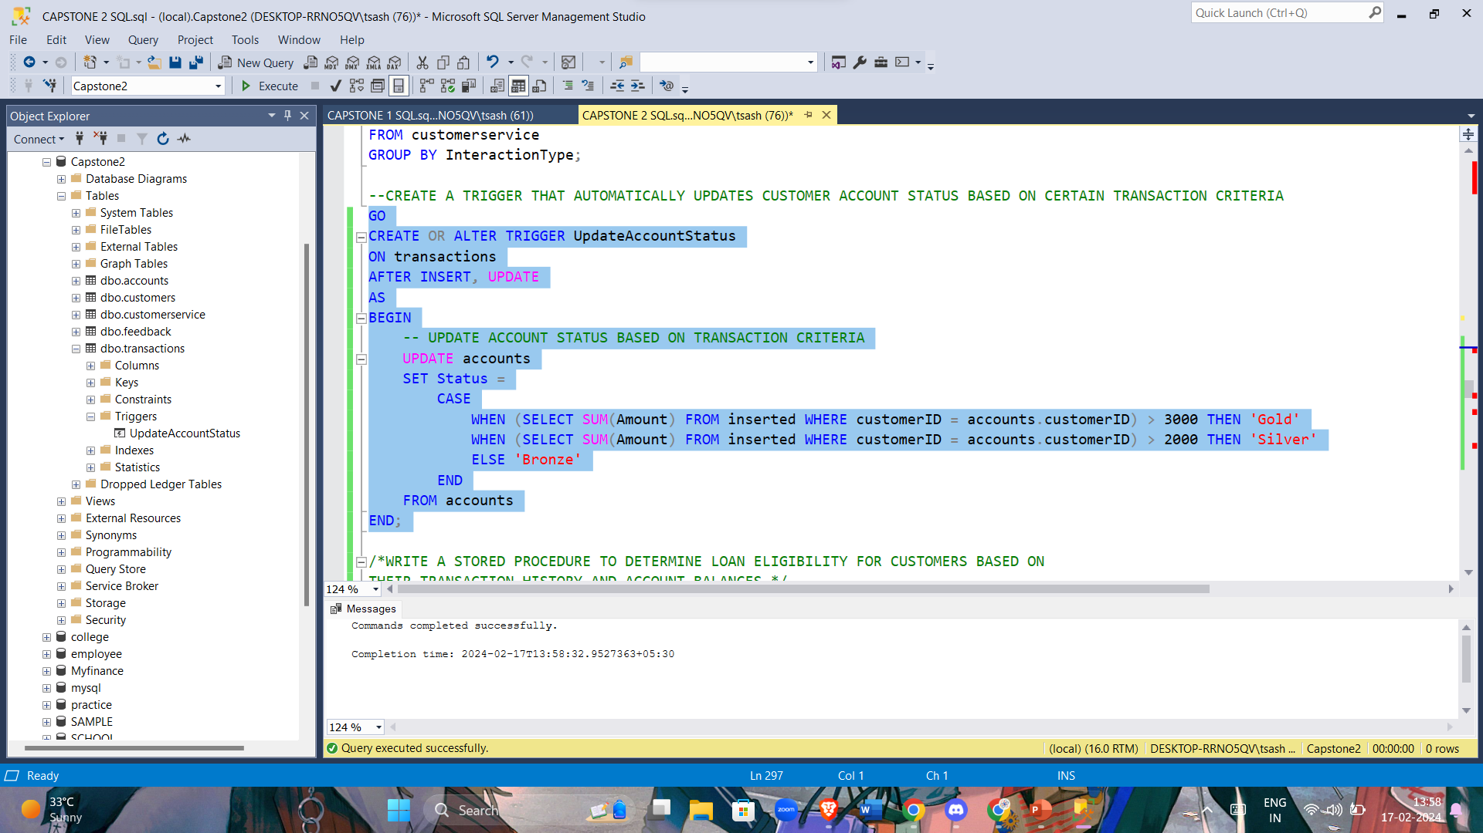

/*WRITE A STORED PROCEDURE TO DETERMINE LOAN ELIGIBILITY FOR CUSTOMERS BASED ON

THEIR TRANSACTION HISTORY AND ACCOUNT BALANCES */

CREATE OR ALTER PROCEDURE Check_Loan_Eligibility

( @accountID INT)

AS

BEGIN

DECLARE @Total_TransactionAmount DECIMAL(10, 2);

DECLARE @AccBalance DECIMAL(10, 2);

DECLARE @Eligibility_Status VARCHAR(50);

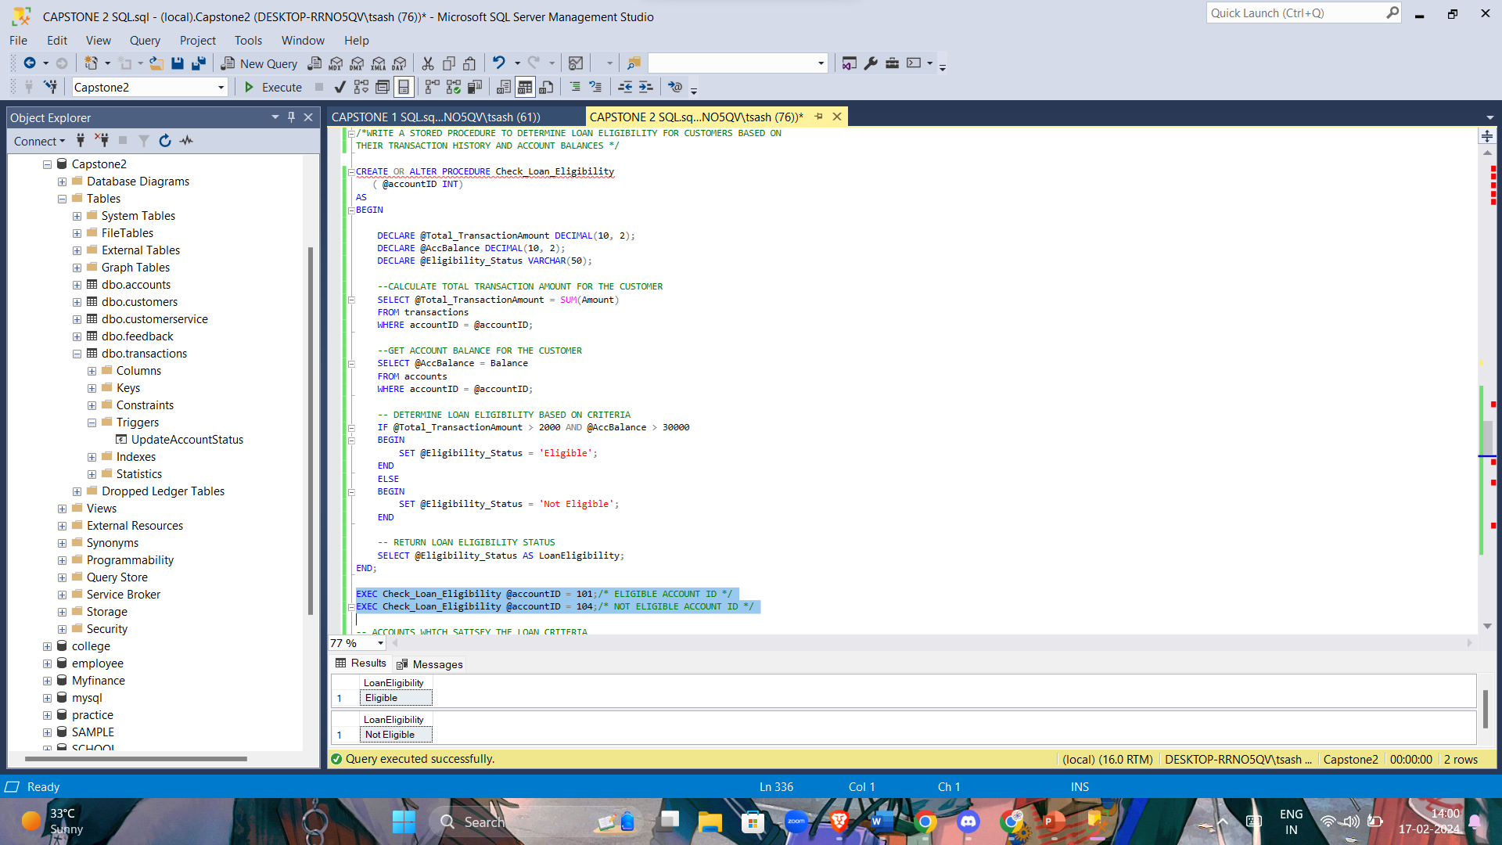

--CALCULATE TOTAL TRANSACTION AMOUNT FOR THE CUSTOMER

SELECT @Total_TransactionAmount = SUM(Amount)

FROM transactions

WHERE accountID = @accountID;

--GET ACCOUNT BALANCE FOR THE CUSTOMER

SELECT @AccBalance = Balance

FROM accounts

WHERE accountID = @accountID;

-- DETERMINE LOAN ELIGIBILITY BASED ON CRITERIA

IF @Total_TransactionAmount > 2000 AND @AccBalance > 30000

BEGIN

SET @Eligibility_Status = 'Eligible';

END

ELSE

BEGIN

SET @Eligibility_Status = 'Not Eligible';

END

-- RETURN LOAN ELIGIBILITY STATUS

SELECT @Eligibility_Status AS LoanEligibility;

END;

EXEC Check_Loan_Eligibility @accountID = 101;/* ELIGIBLE ACCOUNT ID */

EXEC Check_Loan_Eligibility @accountID = 104;/* NOT ELIGIBLE ACCOUNT ID */

-- ACCOUNTS WHICH SATISFY THE LOAN CRITERIA

SELECT accountID FROM accounts

WHERE Balance>30000 AND accountID IN (SELECT accountID FROM transactions WHERE Amount>2000);

--USE WINDOW FUNCTIONS TO ANALYZE CUSTOMER RETENTION OVER THE YEARS

SELECT

YEAR(JoiningDate) AS Joining_Year,

COUNT(DISTINCT customerID) AS Total__Customers,

LAG(COUNT(DISTINCT customerID)) OVER (ORDER BY YEAR(JoiningDate)) AS Previous_Year_Customers,

ROUND((COUNT(DISTINCT customerID) * 100.0) / LAG(COUNT(DISTINCT customerID)) OVER (ORDER BY YEAR(JoiningDate)),2) AS Retention_Rate

FROM customers

GROUP BY YEAR(JoiningDate);

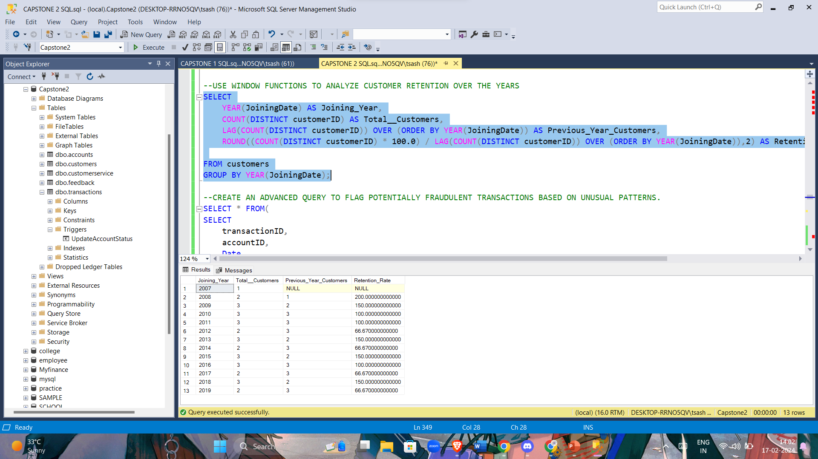

--CREATE AN ADVANCED QUERY TO FLAG POTENTIALLY FRAUDULENT TRANSACTIONS BASED ON UNUSUAL PATTERNS.

SELECT * FROM(

SELECT

transactionID,

accountID,

Date,

Amount,

CASE

WHEN Amount > 3000 THEN 'HighAmount'

WHEN Amount < 0 THEN 'NegativeAmount'

ELSE NULL

END AS Flag_Reason

FROM

transactions) AS FLAG

WHERE Flag_Reason IS NOT NULL;

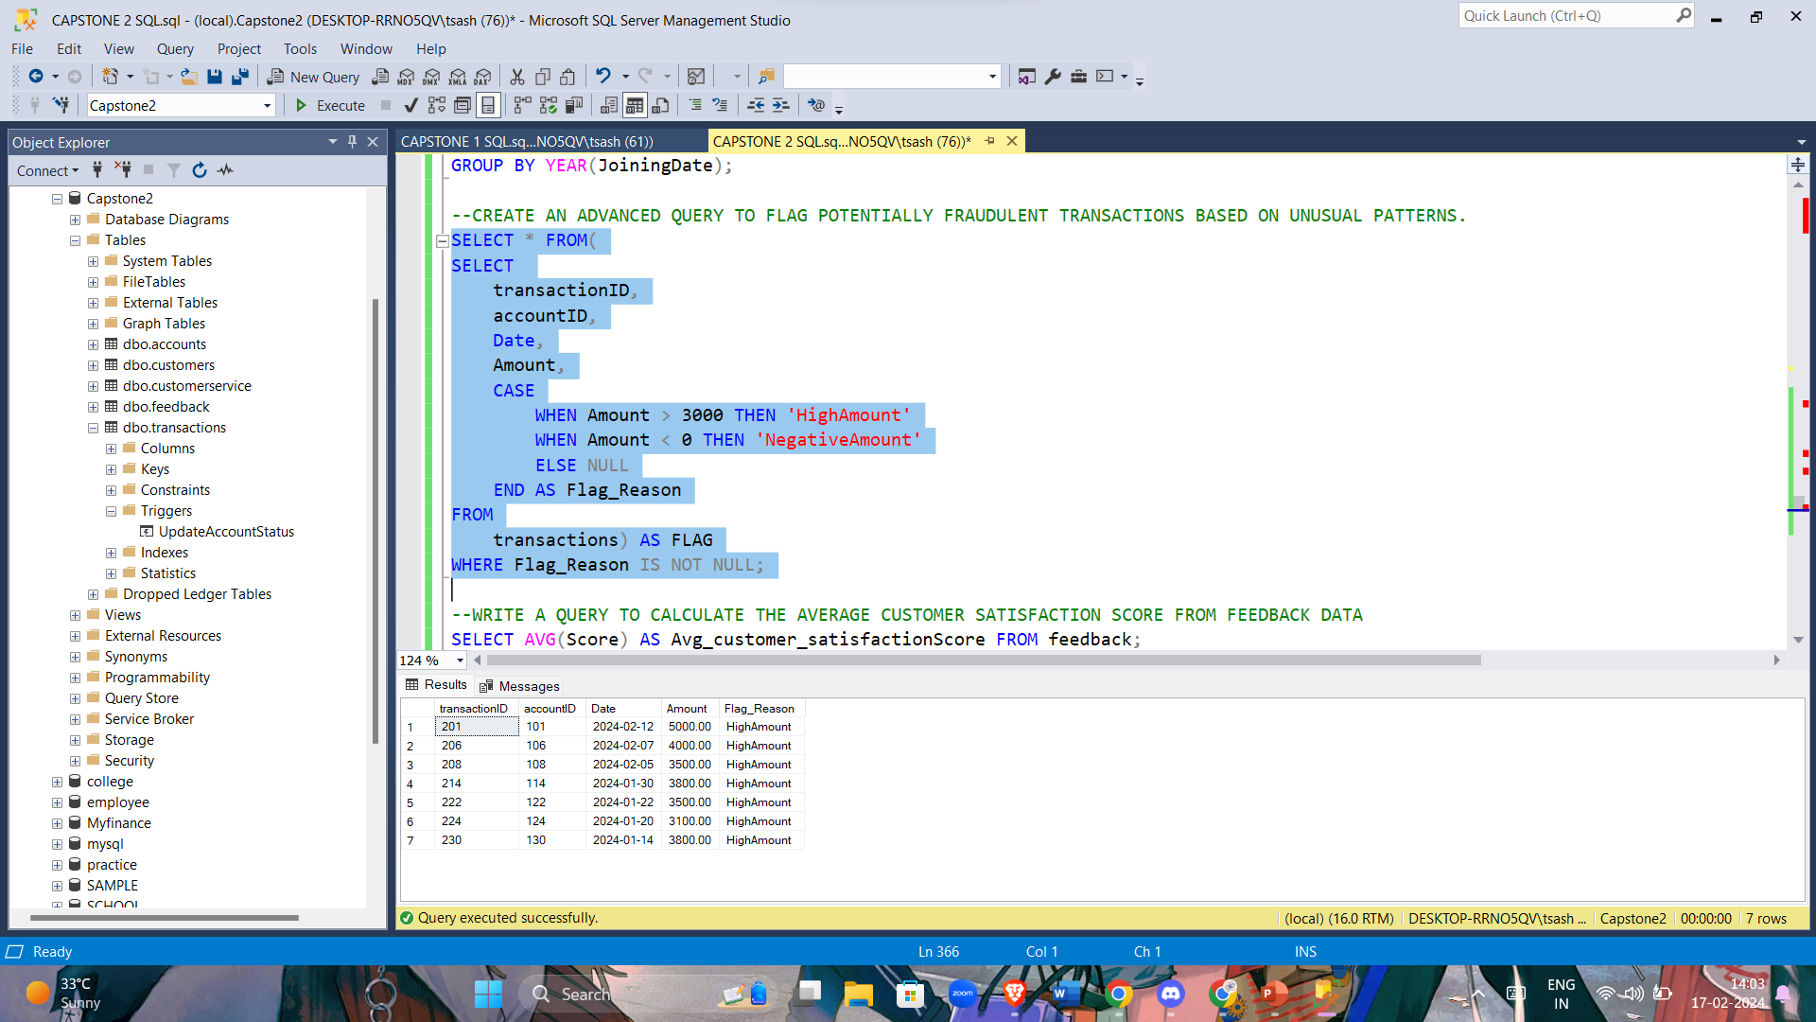

--WRITE A QUERY TO CALCULATE THE AVERAGE CUSTOMER SATISFACTION SCORE FROM FEEDBACK DATA

SELECT AVG(Score) AS Avg_customer_satisfactionScore FROM feedback;

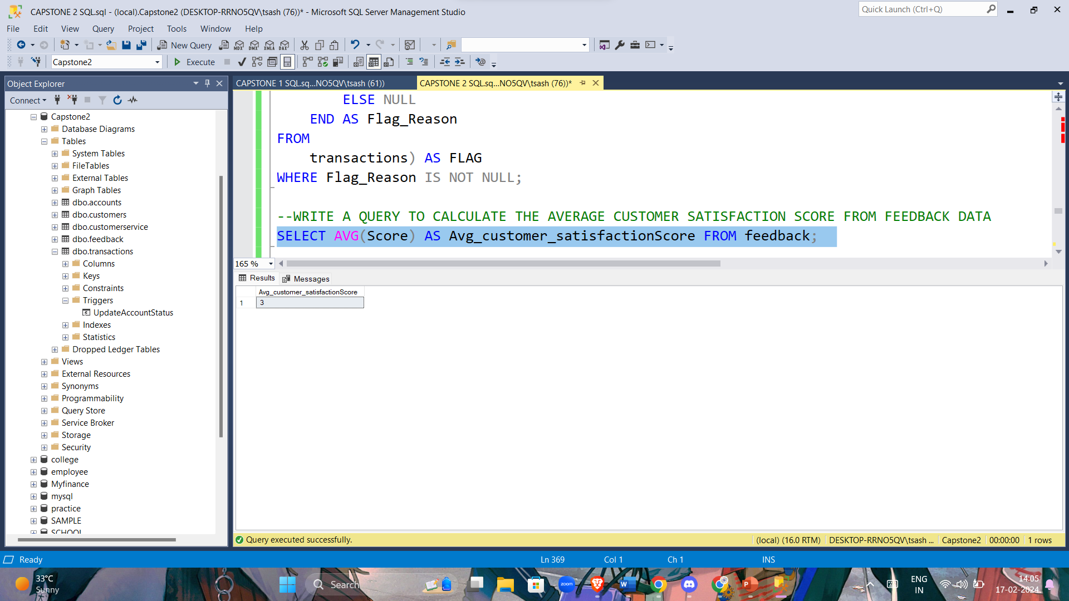

--CREATE A USER-DEFINED FUNCTION TO CALCULATE INTEREST FOR DIFFERENT ACCOUNT TYPES

GO

CREATE OR ALTER FUNCTION Calculate_Interest(

@AccountType VARCHAR(50)

)

RETURNS DECIMAL(18, 2)

AS

BEGIN

DECLARE @Interest_rate DECIMAL(18, 2);

SET @Interest_rate =

CASE

WHEN @AccountType = 'Savings' THEN 0.02 -- 2% INTEREST RATE FOR SAVINGS ACCOUNT

WHEN @AccountType = 'Checking' THEN 0.01-- 1% INTEREST RATE FOR SAVINGS ACCOUNT

ELSE 0 -- NO INTEREST FOR OTHER ACCOUNT TYPES

END

RETURN @Interest_rate

END

--INTEREST RATE FOR THE CUSTOMER BASED ON ACCOUNT TYPE

SELECT

accountID,

accountType,

Balance,

Interest_rate = Balance + ( Balance * dbo.Calculate_Interest(AccountType))

FROM accounts

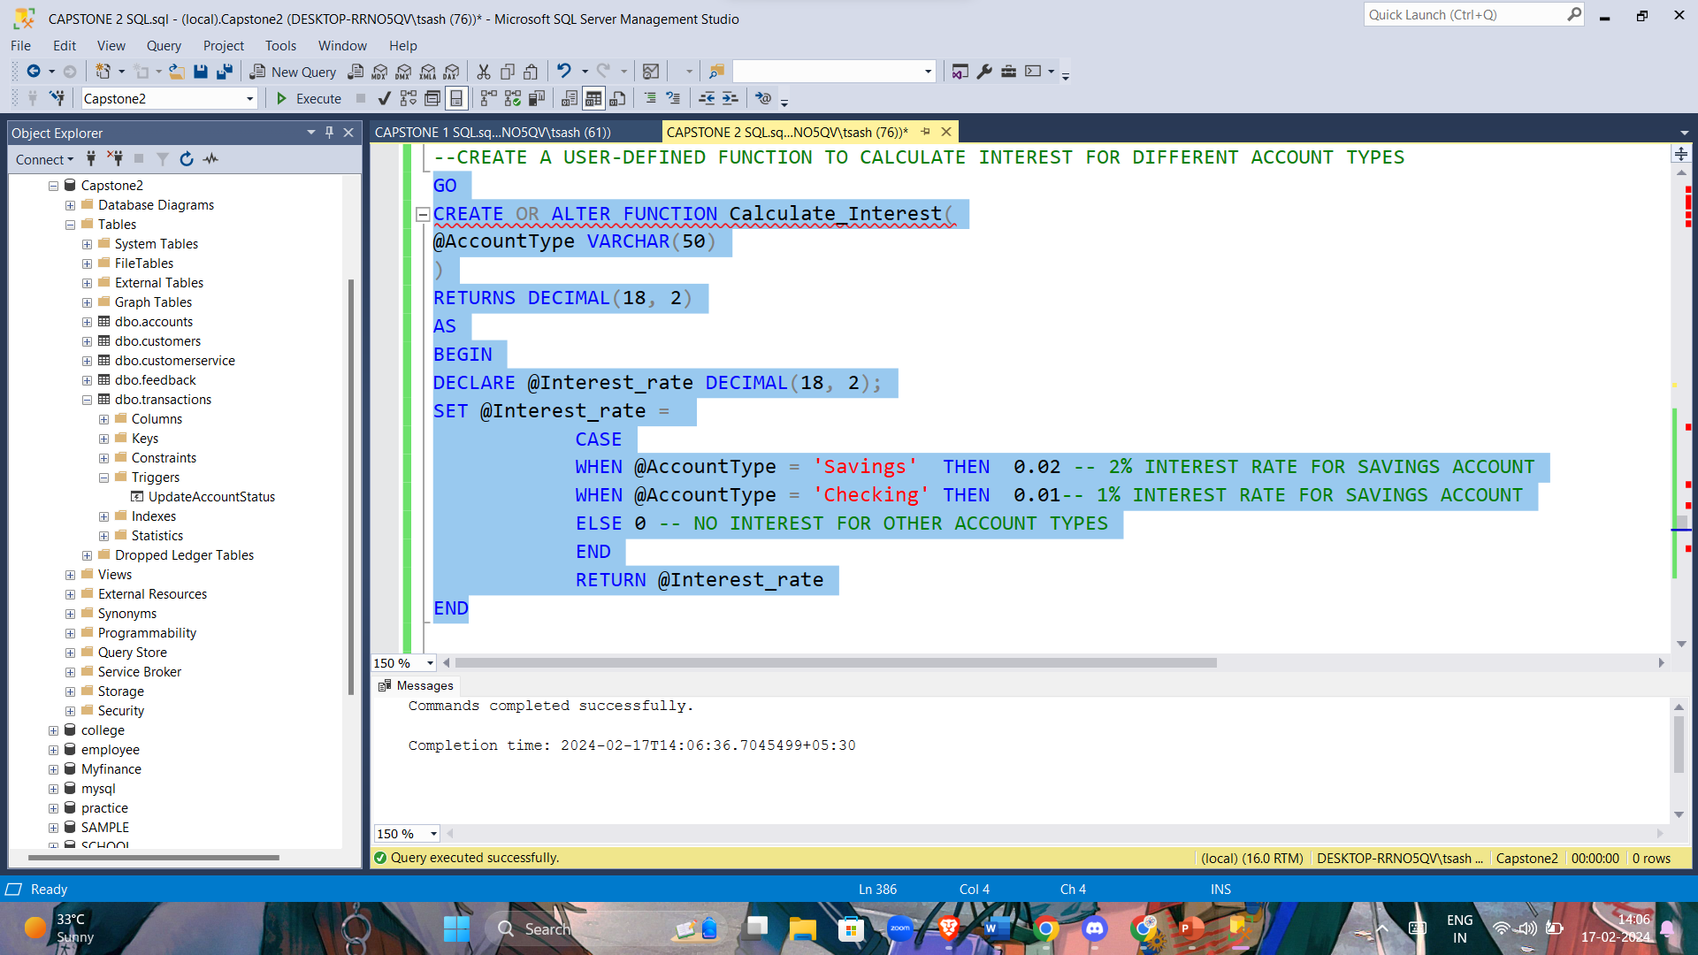

--DEVELOP A USER-DEFINED FUNCTION TO ASSESS CREDIT SCORES BASED ON CUSTOMER TRANSACTION HISTORY AND ACCOUNT BALANCES

CREATE OR ALTER FUNCTION AssessCreditScore

(

@CustomerID INT

)

RETURNS INT

AS

BEGIN

DECLARE @CreditScore INT;

-- CALCULATE CREDIT SCORE BASED ON AVERAGE ACCOUNT BALANCE

SELECT @CreditScore =

CASE

WHEN AVG(Balance) > 10000 THEN 800

WHEN AVG(Balance) > 5000 THEN 700

ELSE 600

END

FROM

accounts

WHERE

CustomerID = @CustomerID;

RETURN @CreditScore;

END;

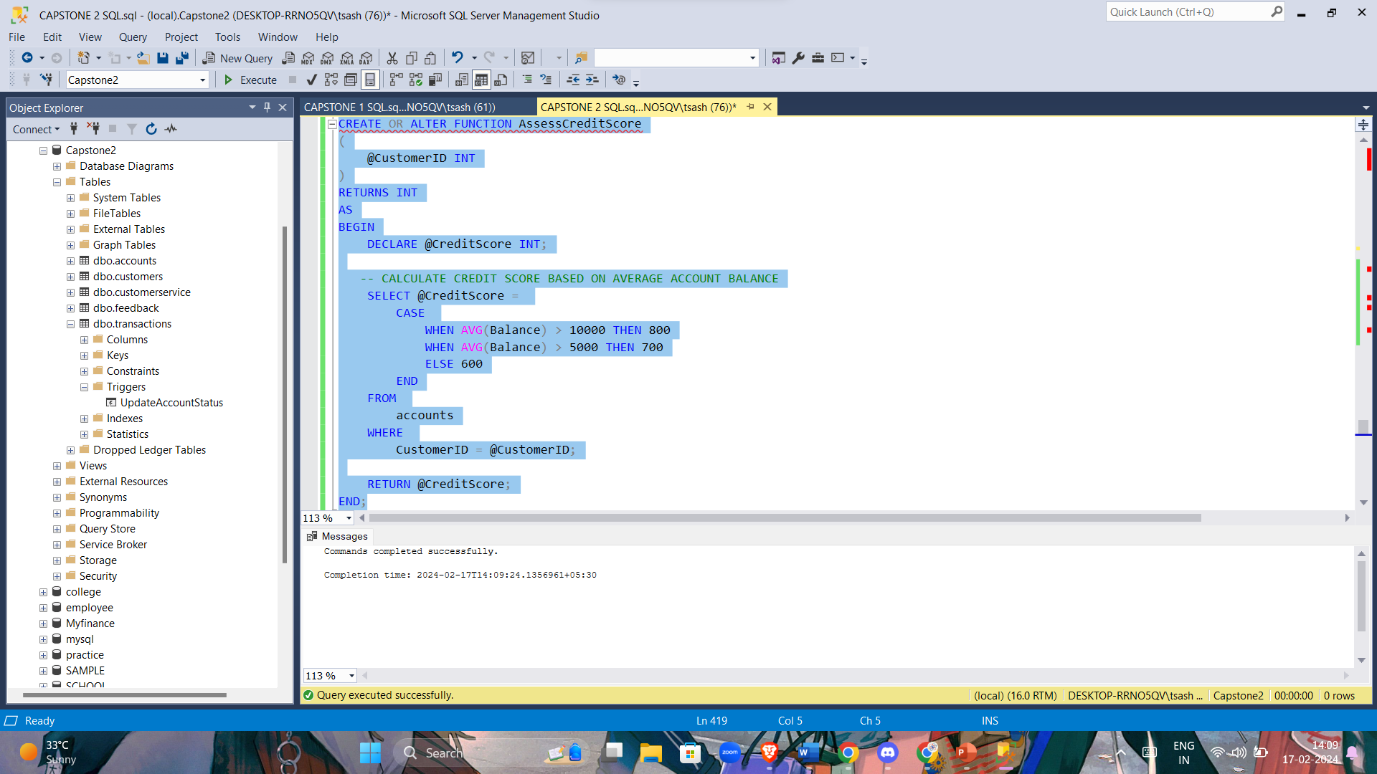

--WRITE A SQL TRANSACTION SCRIPT THAT ROLLS BACK A TRANSACTION IF AN ATTEMPT TO UPDATE AN ACCOUNT BALANCE FAILS.

BEGIN TRANSACTION;

UPDATE accounts

SET Balance = Balance - 100 -- HERE WE ARE DEBITING A AMOUNT OF 100/-

WHERE accountID = 101; -- ACCOUNT ID OF THE USER

IF @@ROWCOUNT = 0

BEGIN

ROLLBACK TRANSACTION;

PRINT 'Failed to update account balance. Transaction rolled back.';

END

ELSE

BEGIN

COMMIT TRANSACTION;

PRINT 'Account balance updated successfully.';

END

SELECT * FROM accounts;

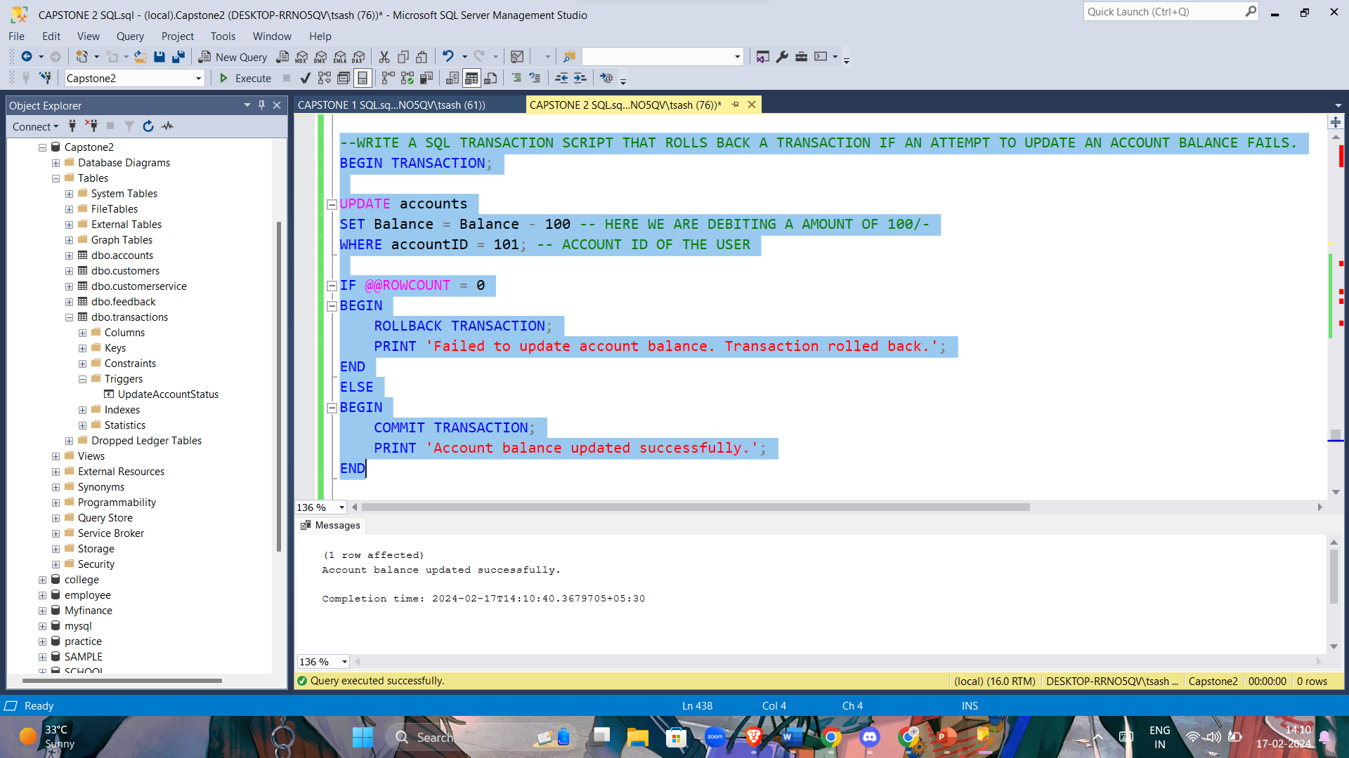

/*IMPLEMENT A SEQUENCE TO AUTOMATICALLY GENERATE UNIQUE TRANSACTION ID

VALUES FOR NEW ENTRIES IN THE TRANSACTIONS TABLE.*/

-- ALTER THE TABLE TO ADD AN IDENTITY COLUMN

ALTER TABLE transactions

ADD transactionID INT IDENTITY(1,1) PRIMARY KEY;

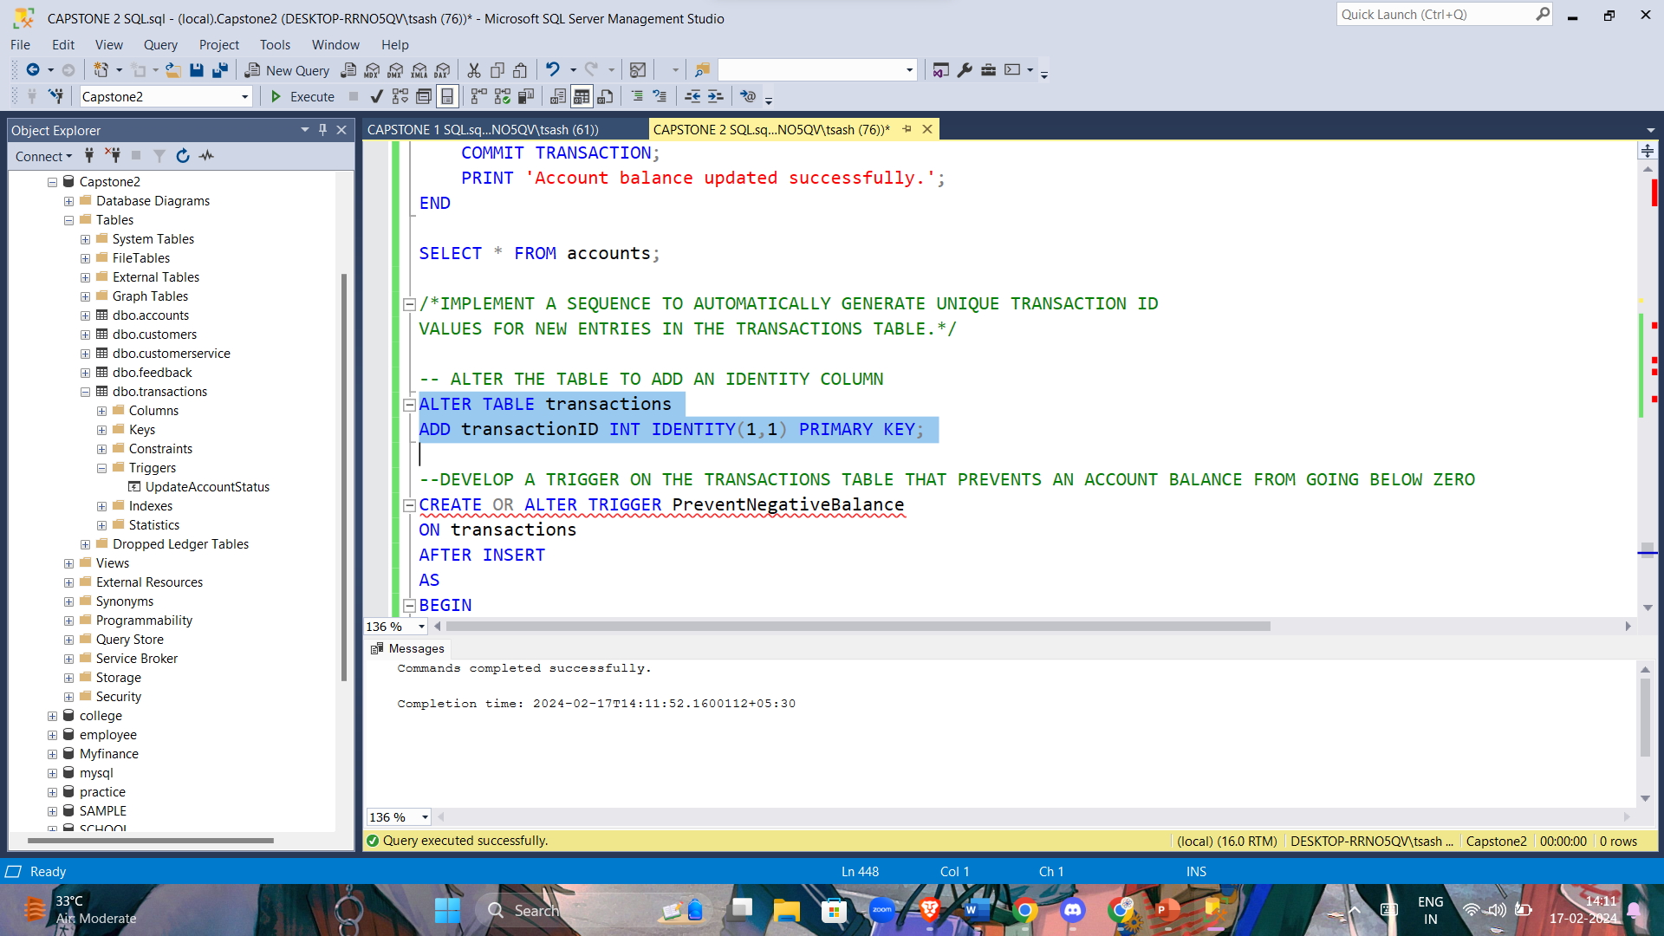

--DEVELOP A TRIGGER ON THE TRANSACTIONS TABLE THAT PREVENTS AN ACCOUNT BALANCE FROM GOING BELOW ZERO

CREATE OR ALTER TRIGGER PreventNegativeBalance

ON transactions

AFTER INSERT

AS

BEGIN

-- CHECK FOR NEGATIVE ACCOUNT BALANCES AFTER THE NEW TRANSACTION

IF EXISTS (

SELECT 1

FROM accounts i

JOIN Transactions t

ON i.accountID = t.accountID

WHERE i.Balance + t.Amount < 0

)

BEGIN

-- ROLLBACK THE TRANSACTION IF A NEGATIVE BALANCE OCCURS

ROLLBACK TRANSACTION;

PRINT 'Transaction rollback: Negative balance prevented.';

END

END;

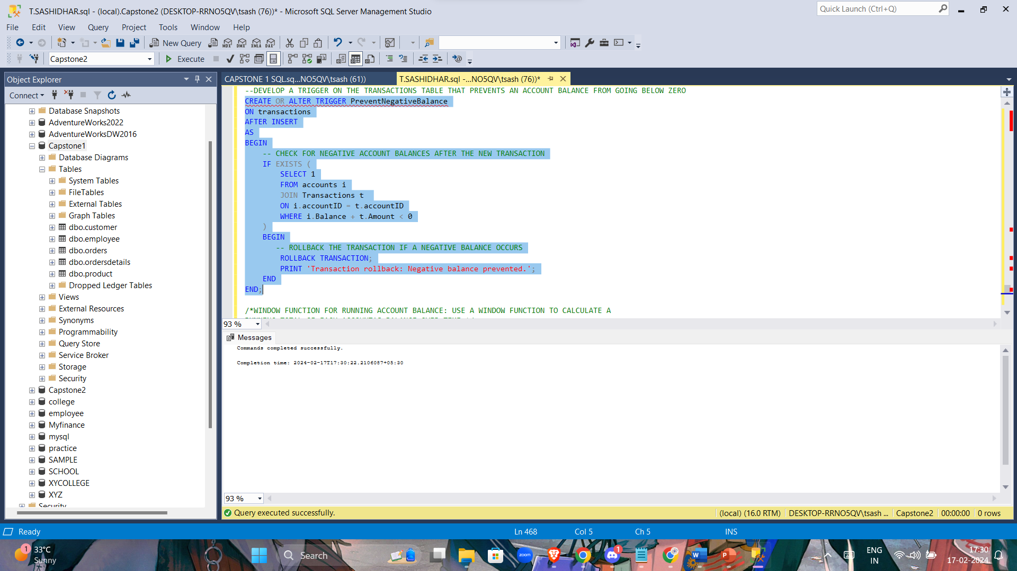

/*WINDOW FUNCTION FOR RUNNING ACCOUNT BALANCE: USE A WINDOW FUNCTION TO CALCULATE A

RUNNING TOTAL OF EACH ACCOUNT'S BALANCE OVER TIME.*/

SELECT

customerID,

accountID,

OpeningDate,

Balance,

SUM(Balance) OVER (PARTITION BY accountID ORDER BY OpeningDate) AS Running_Balance

FROM

accounts;

